

RAFFLES INSTITUTION (JUNIOR COLLEGE)
PRELIMINARY EXAMINATION 2009

Higher 2

CANDIDATE
NAME

CLASS INDEX NUMBER

CHEMISTRY 9746/02

Paper 2 Structured Questions 23 September 2009

1 hour 30 minutes
Candidates answer on the Question Paper.

Additional Materials: Data Booklet

READ THESE INSTRUCTIONS FIRST

Write your name, class and index number in the spaces provided on the top of this page.
Write in dark blue or black pen in the spaces provided.
You may use a soft pencil for any diagrams, graphs or rough working.
Do not use staples, paper clips, highlighters, glue or correction fluid.

Answer all questions.
A Data Booklet is provided. Do not write anything on it.
You are reminded of the need for good English and clear presentation in your answers.

The number of marks is given in brackets [ ] at the end of each question or part question.

For Examiner’s Use

Question | 1 | 2 | 3 | 4 | 5 | Total
Marks | /10 | /14 | /11 | /11 | /14 | /60

This document consists of 14 printed pages.
Answer all questions in the spaces provided.
For Examiner’s Use

1 Fluorine is the most reactive of all elements and even combines with all noble gases except helium and neon. Compounds containing the element fluorine are commonly called fluorides.

(a) (i) Give the electronic configuration of fluorine, F.

- On the axes below, sketch the shape(s) of the singly–occupied orbital(s) in an atom of F at ground state.
x
y
z

[2]

(b) With reference to the Data Booklet, briefly explain the following statements.

- The first ionisation energy of oxygen is lower than that of fluorine.

- The second ionisation energy of oxygen is higher than that of fluorine.

[3]
(c) It is well known that fluoride, F–, helps prevent tooth decay. Hence, it is commonly added to toothpastes, mouth rinses and water supplies via water–soluble compounds such as sodium fluoride.
For Examiner’s Use

However, in high concentrations, F– is lethal. Historically, most cases of fluoride poisoning have been caused by the accidental ingestion of insecticides containing F– but currently, most cases have been due to the swallowing of toothpaste.

A suggested method of treatment in the case of accidental ingestion is to give the person some milk of magnesia, which is an aqueous suspension of magnesium hydroxide, Mg(OH)₂(s).

(i) Given that stomach juices are highly acidic, write a balanced equation, with state symbols, for the reaction that occurs when some milk of magnesia enters the stomach.

(ii) MgF₂(s) is a sparingly soluble salt. The numerical value of its solubility product is 5.16 × 10^{–11} at 25 ºC.
Based on your answer to (c)(i), suggest how a person who has accidentally swallowed some toothpaste may be successfully treated by drinking some milk of magnesia.

Give a balanced equation, with state symbols, to support your answer.

(iii) Using the data below, determine the minimum volume of the milk of magnesia to be taken, so that the first trace of precipitate forms, if a person has swallowed an amount of toothpaste that has an equivalent of 1.0 mg of F–.
For Examiner’s Use

average volume of liquid in stomach | 1 dm³
amount of Mg(OH)₂ in 1 dm³ of Brand X milk of magnesia | 1.40 mol

Assume that the volume of milk of magnesia swallowed is negligible compared to the volume of liquid in stomach.

[5]
[Total: 10]

2 Air is composed of mainly nitrogen and oxygen, with trace quantities of other gases such as argon, carbon dioxide and even ammonia.

(a) What do you understand by the term ideal gas?

[1]

(b) (i) A sketch of pV against p for 1 mole of an ideal gas at 100 ºC is given below.
For Examiner’s Use

pV
ideal gas
p
0

On the same axes, show how 1 mole each of carbon dioxide and ammonia will behave at 100 ºC. Label your graphs clearly.
(ii) Briefly explain your answer to (b)(i).

[2]

In nature, the gases nitrogen and oxygen can react to form nitrogen monoxide, NO. However, the reaction requires elevated temperatures.

- (i) Suggest how NO can be formed in nature.

(ii) Briefly explain why elevated temperatures are needed for the formation of NO.

[2]
The formation of NO has been studied as an equilibrium system.
For Examiner’s Use

N₂(g) + O₂(g) 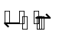 2NO(g)

(d) Write an expression for the equilibrium constant, K_{c}, for the reaction.

[1]
An experiment is carried out using the set–up below.

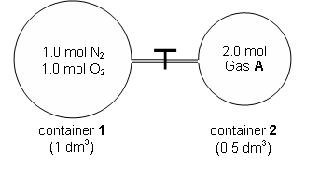
(e) To begin the reaction, the temperature is raised to 2000 ºC without opening the valve.

Given that the numerical value of K_{c} is 6.2 x 10^{–14} at 2000 ºC, calculate the concentration of NO present when the system reaches equilibrium.

[2]
(f) When the system in (e) has reached equilibrium, the valve is opened at constant temperature.
For Examiner’s Use

Predict, and explain your answers briefly, how the position of equilibrium will change if gas A is

- argon,

- nitrogen.

[3]
(g) With reference to (f)(ii), calculate the final pressure of NO when equilibrium is re–established.

[3] [3]
[Total: 14]
3 The flowchart below shows reactions involving some calcium compounds.
For Examiner’s Use
heat
CaCO₃(s) gas A + solid B
H₂O(l)
HCl (aq)
CO₂ (g)

solid D solution C solution E

(a) Coal-fired power stations emit flue gases, which contain the oxides of nitrogen, carbon and sulfur. To reduce sulfur dioxide emission, such power station is fitted with a flue gas desulfurisation (FGD) plant which uses a slurry of compound D to extract sulfur dioxide gas from the flue gases.

- Suggest the identity of compound D. Hence write an equation for its reaction with sulfur dioxide, given that one of the products produced is a sulfite.

- Calculate the mass of compound D required to extract the sulfur dioxide produced when 1 × 10⁹ kg of coal containing 2.5 % of sulfur by mass are burnt.

[4]

(b) With the aid of equation(s), suggest why solution E has a pH of 7 whereas a solution of beryllium chloride has a pH of approximately 3.

[3]
- The graph below shows the change in mass when 1.00 g of calcium carbonate was heated at 900 ºC.
For Examiner’s Use
x
1.00

0

Mass / g
Decomposition curve of CaCO₃

time

  - Calculate the value of x.

  - On the same axes above, sketch the graph that illustrates the change in mass when 1.00 g of magnesium carbonate was heated at 900 ºC until there was no change in mass.

(iii) Using relevant data from the Data Booklet, compare the thermal stabilities of the two carbonates to account for your sketch in (c)(ii).

[4] [Total: 11]
4 Eugenol is used in perfumes, flavourings, essential oils and in medicine as a local antiseptic and anaesthetic. It was used in the production of isoeugenol for the manufacture of vanillin, but vanillin is now mostly produced from phenol.
For Examiner’s Use

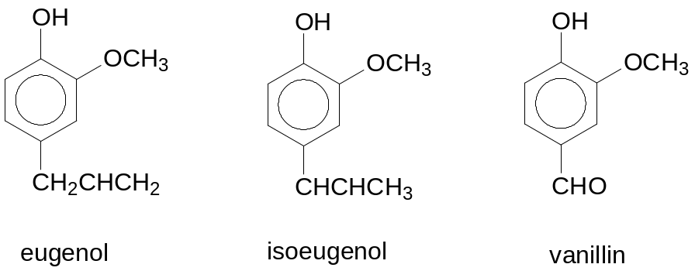

(a) What type of isomerism do eugenol and isoeugenol exhibit?

[1]

(b) Isoeugenol exists as a pair of stereoisomers. Draw the structures of the isomers and state the type of stereoisomerism shown.

[2]

(c) 16.4 g of eugenol yield 13.0 g of vanillin. Calculate the percentage yield of vanillin.

[2]
(d) Name a reaction in which the three compounds react similarly, and give the structure of the major organic product formed from eugenol.
For Examiner’s Use

[2]

(e) By means of a chemical test, show how you would distinguish vanillin from eugenol.

[2]

(f) A synthesis route from compound A, an isomer of vanillin, to compound B is shown below.

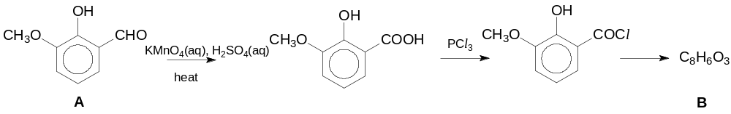

Write the structure of compound B and briefly explain why its yield may be low.

[2]
[Total: 11]
5 (a) The graph below shows the effect of temperature on the α-helix structure of a polypeptide chain found in a protein.
For Examiner’s Use

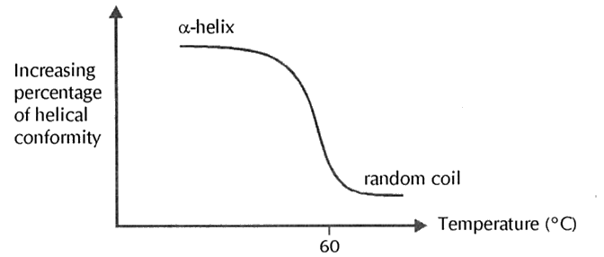

(i) One of the common secondary structures of proteins is the α-helix. Draw a diagram to show how two groups in a protein could be involved in maintaining the structure of the α-helix.

(ii) Explain what happens to the α-helix structure in proteins at temperatures above 60 ºC.

(iii) Suggest another condition which can achieve what you have described in (a)(ii).

[5]

(b) Gastrins are heptadecapeptide (17 amino acid units) hormones that help regulate the secretion of gastric acid in the mammalian stomach. The polypeptide found in a cat stomach can be digested with the appropriate enzyme and the four peptide fragments formed are shown. Another four fragments are formed when the same polypeptide is digested with an enzyme from the human digestive system.
For Examiner’s Use

With feline enzyme:
Glu-Gly-Pro-Gly-Trp
Ala-Tyr-Trp
Met-Asp-Phe
Leu-Glu-Glu-Glu-Glu-Ala

With human enzyme:
Glu-Glu-Glu-Glu
Ala-Ala-Tyr-Trp-Met
Asp-Phe
Glu-Gly-Pro-Gly-Trp-Leu

State a possible primary structure of gastrin based on the information given above.

[1]
(c) Describe the protein components of haemoglobin.

[2]
(d) Myoglobin is a protein found in muscle tissues which consists of a single polypeptide chain made up of 153 amino acid residues. The diagram below shows the structure of a fragment of the protein myoglobin which contains 5 amino acids.
For Examiner’s Use

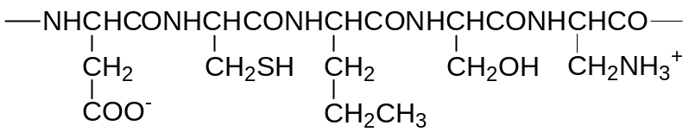

Name and show with diagrams, three types of side-chain interactions that could be involved in the maintenance of the tertiary structure of a protein.

Type of interaction | Diagram illustrating type of interaction
[6]
[Total: 14]

End of Paper

